1) curl -fsSL https://www.mongodb.org/static/pgp/server-4.4.asc | sudo apt-key add -
2) apt-key list

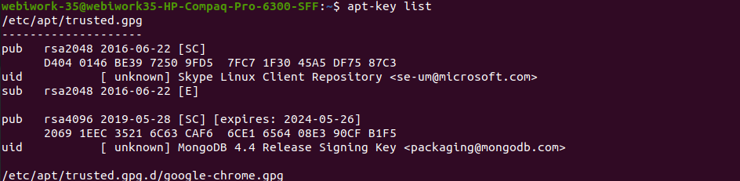

3) echo "deb [ arch=amd64,arm64 ] https://repo.mongodb.org/apt/ubuntu focal/mongodb-org/4.4 multiverse" | sudo tee /etc/apt/sources.list.d/mongodb-org-4.4.list

4) sudo apt update

5) sudo apt install mongodb-org

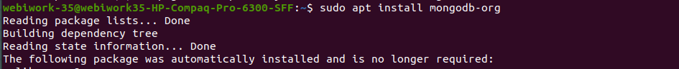

6) sudo systemctl start mongod.service
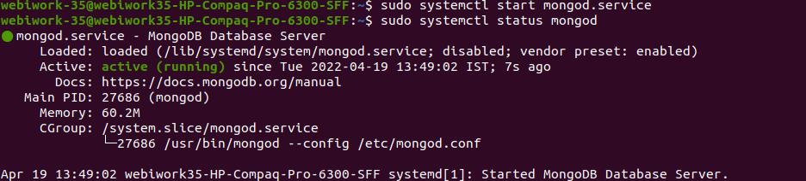
7) sudo systemctl status mongod

8) sudo systemctl enable mongod

------Check Status------
8) sudo systemctl status mongod
9) sudo systemctl stop mongod // for stop service
10) sudo systemctl restart mongod // for restart service

-------For Reference-----
https://www.digitalocean.com/community/tutorials/how-to-install-mongodb-on-ubuntu-20-04

-------Create User in MongoDb-------
1) mongo
2) use admin
3) db.createUser(
{ user: "XXXX",
pwd: "XXXX",

roles:[{role: "dbAdmin" , db:"helixsense"}]})

4) drop user--
db.dropUser(“Username”)

---For change port of MongoDb use command-----
nano /etc/mongod.conf
and restart service
sudo systemctl restart mongod // for restart service

* make connection url

mongodb://<username>:<password>@ec2-3-125-248-157.eu-central-1.compute.amazonaws.com:<port>/<database_name>?authSource=admin&readPreference=primary&appname=MongoDB%20Compass&directConnection=true&ssl=false

<@ec2-3-125-248-157.eu-central-1.compute.amazonaws.com> replace with your current host

-------Take reference form this---------
https://www.geeksforgeeks.org/create-user-and-add-role-in-mongodb/

